**CALVARY CALLER**

July, 2022

Church Office 920-793-3917

Office Hours: 11a – 2p, Mon - Thurs

[contactus@calvarytr.org](mailto:contactus@calvarytr.org)

PASTOR’S PONDERINGS

“A Midsummer Nightmare”

So I get a call from Joy Carlson: “Bruce, did you send out the article for next month’s newsletter?”

Ah, article? It’s time for that already? So, the answer: “No, I simply forgot.” A pause then, and I continue, “Actually, I thought about it earlier but nothing came to mind. Sorry.” Then I try to cover by adding that parishioners—not seeing that lengthy article at the beginning of the newsletter—will be more likely to read it!”

Joy laughs, and then joins into the ‘it’s okay to have forgotten’ theme with sharing alternatives that she can search out. Yet I know this means more work for her as she tries find some appropriate piece.

FORGIVENESS – It’s the one thing we uniquely have as followers of the living Christ. “How many times shall my brother sin against me, and I forgive him?” asks Peter. “As many as seven times?” He’s taken the rabbinic teaching of forgiving three times. Then he’s doubled it and added one for good measure!

Jesus will have nothing to do with the numbers game. “I tell you Peter, you forgive as many as seventy times seven!” Seven was seen as the perfect number. It’s multiplication by seven meant ‘infinity.’ It’s a memorable way of saying, “You forgive every time!” EVERY SINGLE TIME!

………………………………..

It is—in a sense—the one contract we have and it’s unique with us: “Forgive us our trespasses as we forgive those who trespass against us.”; and from the Lord’s prayer it moves into the Apostles Creed: “I believe in the communion of saints, the forgiveness of sins…“

It’s wonderful, this saying. It makes everything easy.

It’s terrible, this saying. It makes ‘life together’ almost impossible!

“They better repent and change their ways. Then, maybe, I’ll forgive them. Forgive, but not forget.” “It makes no sense, really, to forgive if he’s not really asking for forgiveness.” And so we go on with an endless number of reasons—good reasons—to have life be about ‘us’ verses ‘them,’ those who are ‘in’ and those who are ‘out.’

……………………………………….

Or, we simply give it a shot, this direction of caring for others—all others—the way Jesus cares for us. It doesn’t mean we accept harmful behavior from others or hide our feelings by with-holding ‘telling the truth in love.” But it does mean that we daily move toward the alienated one. And pray for or about them.

………………………………………..

So I hurriedly write this musing on ‘forgiveness’ knowing that terming my failing ‘A Midsummer’s Nightmare’ is a bit overstated. It’s a ‘hurried’ article, lacking appropriate illustrations and lilt. By the time it’s sent to our two congregations it likely won’t be needed, but I got to think about forgiveness; got to experience the joy of receiving it from Joy and the day holds the possibility of trying again to do the ‘seventy times seven’ thing.

I feel better now. Forgiveness always does that.



**Worship**

***July services will be as follows:***

|  |  |  |  |  |  |
| --- | --- | --- | --- | --- | --- |
| *Month* | *Worship Leader* | *Church* |  | | |
| July 3rd | Al Willems | Calvary | | |  |
| July 10th | Stan Phelps | Calvary | | |  |
| July 17th | Rita Kreeger | Calvary | | |  |
| July 24th | Pastor  Kim Henning | Joint Picnic;  Lincoln Park | | |  |
| July 31st | Pastor  Kim Henning | Calvary | |  | |

***On July 24th we will be having the first Joint Picnic at Lincoln Park; Cabin 1 from 10 am – 2 pm ☺***

***There are sign-up sheets for volunteering to help set up, what food item you would like to bring and set up kid games!***

Come celebrate worship together, we can’t wait to see you!

If you are in need of transportation, please feel free to contact the office and we will see how we can helpl you.



**Transition Update**

Baby items are still being collected for InCourage in the gathering space; specifically:

* Size 4 - 6 diapers; Pull-ups
* Wipes
* Diaper rash cream
* Baby bottles & Juice boxes



Calvary and St Paul met on 20th to discuss ways to work together on planning services and acquiring people to lead the services. Progress was made and hopefully we can identify other ways to work cooperatively.

We do have two supply ministers, Pastor Batt and Pastor Henning. Lay leaders from both churches have indicated that they are willing to serve at both sites.

We hope to identify other areas that we can work on cooperatively.



**Happy Birthday!!!**

|  |  |
| --- | --- |
| 5th | Nicholas Whitehouse |
| 9th | **Katherine Wirer** |
| 11th | **Cass Shimanek** |
| 12th | **Darlene Laurin** |
| 16th | **Jean Hoffman** |
| 19th | **Barb Jensen** |
| 23rd | **Cheryl Philipps** |
| 24th | **Garth Landon** |
| 30th | **Donald Stutzman** |
| 30th | **Zachary Whitehouse** |

**Happy Anniversary!!!**

|  |  |
| --- | --- |
| 11th | Scott & Roxanne Spiering |

***In Our Prayers***



Bill, Amy, Laurie, Sue, John, Carol, Margaret, Jane, Louise, Deanna, Scott, Melody, Kyle, Richard & Joanne, Judah, Dave, Bailey, Cannon, Lindsay, Pat, Jennifer and her family, The Whitehouse Family, Judy Juda

We ask that you obtain permission from the person to have their name made public.

Your prayers do make a difference.

**The deadline for putting something into the August newsletter is July 15th.**

*Prayer requests can be made by emailing the office at* [contactus@calvarytr.org](mailto:contactus@calvarytr.org), *or by calling* *the church and leaving a message for Jennifer.*

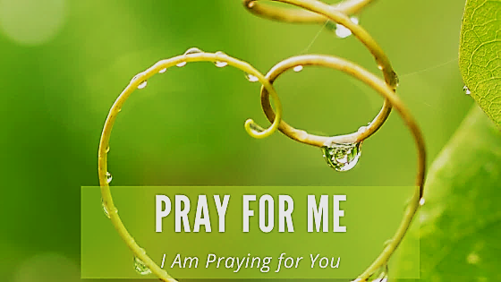

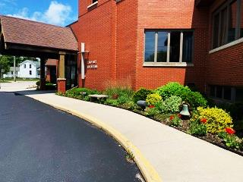

Here is one picture of how lovely they look in the main entrance area! ☺

Thank you to everyone who purchased the geraniums in memory and honor of your children, grandchildren, parents and Ukraine.

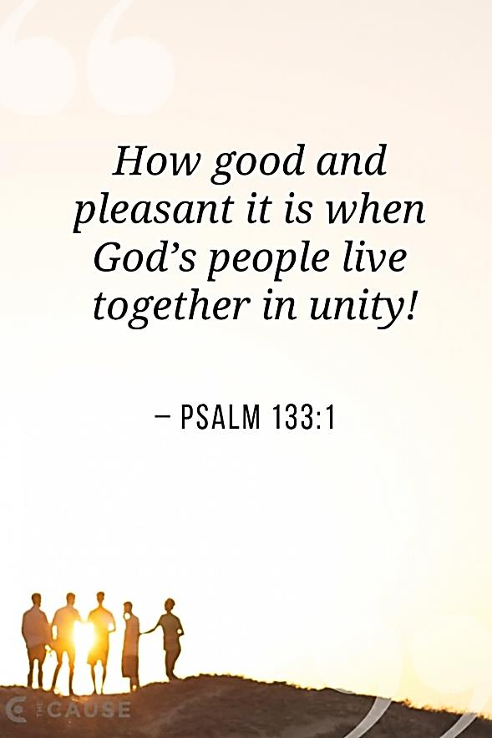



Happy Birthday to the USA!

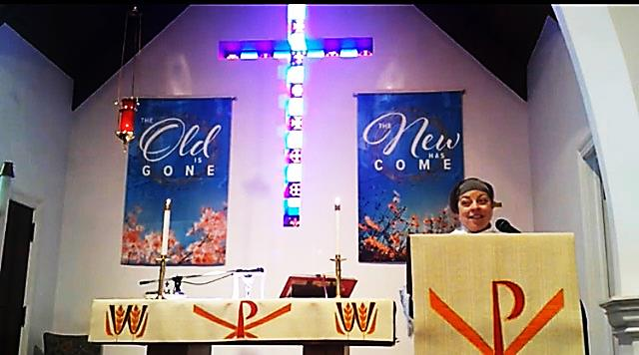

NEW EASTER BANNERS

Thank you, Cindy Schmidt, for the beautiful Easter banner set. They are a gorgeous addition to our banner collection and will be a part of Calvary's Easter celebrations for years to come. We appreciate your generous donation of them in memory of your dear husband, Gary.

Keeping Our Contacts Up To Date!

*Please check your last Calvary directory and verify that all your information is correct. In the past several months, errors in phone numbers and email addresses have been found when the church tried to contact some members. It's important that this information is updated and accurate.*

*If there is an error, please contact the church office to make correction*

***Church Staff & Council Contact information***

**Emergent Pastoral Needs**:

Please contact the office or Cindy Schmidt or Joe Bitto

**Church Office Manager**:

Jennifer Loos

Office Hours: - Mon.-Thurs. SUMMER HOURS 12p – 2p

My office hours are different than my physical hours.

If my availability changes due to appointments, those updates will be sent out via email.

Office Phone: 920-793-3917

(Doors are locked. Please call or use doorbell if you need assistance)

Email: newsletter@calvarytr.org

**Music Ministry:**

Becky Doyen

**Calvary Lutheran’s 2022 Council Members:**

***Executive Officers:***

*President: Cindy Schmidt: 920-901-7449,* *cas3761@gmail.com*

*Vice-president: Joe Bitto: 920-304-6808, bittohoney@charter.net*

*Secretary: Kim Braun: kbalma1@charter.net*

*Treasurer: Ken Mittag*

***Council Members:***

*Diane Grasse: 920-794-8065*; *Barb Jensen:* [*bbjensen77@gmail.com*](mailto:bbjensen77@gmail.com); *Rita Kreeger:* [*rkreeger@charter.net*](mailto:rkreeger@charter.net)

**Follow us on Facebook, our website and our weekly uploaded services on YouTube**



**January 1st – May 30th 2022**

|  |  |
| --- | --- |
| **Capital Improvement Fund** |  |
| Income and Expense Report |  |
| Beginning Balance (Jan 1) | $18,370.70 |
| Cap Improvement Income | $3,594.00 |
| Expenses | $360.38 |
| Ending Balance | $21,604.32 |

|  |  |
| --- | --- |
| **General Budget (GB)** |  |
| Income and Expense Report | |
| General Fund  Income | $33,617.00 |
| General Fund  Expenses | $23,987.00 |
| General Fund  Balance | $9,629.64 |

|  |  |
| --- | --- |
|  |  |

***A Few General Updates***



St. Paul will be having a rummage sale on September 8th, 9th and 10th. Any Calvary member is welcome to donate to this sale. They DO accept clothing but DO NOT want electronics. Items can be dropped off now. They are also checking on the possibility of a women’s retreat this fall.

St Paul is planning a women’s retreat at Imago Dei on Oct 14-15. This will be a great opportunity to get to know each other and work together. More details to follow.

The call committee has an applicant. A Zoom interview will occur in the next couple of weeks. They are not allowed to say any more at this time. Let’s all hope for the best! Continue to pray for our Call Committee and the candidate they will be interviewing shortly.



The online scrip site is now known as RaiseRight. They have an app available as well for the tech savvy! If you are looking for a specific company, you can log onto this site: https://www.raiseright.com/shop

Scrip is available almost every Sunday after church. Here is a listing of local companies that are stocked in our box.

* **BP Gas**
* **Fatzo's**
* **Festival**
* **Kohl's**
* **Kurtz's**
* **KwikTrip**
* **McDonald's**
* **Piggly Wiggly**
* **Roundy's**
* **Sauve's (gas)**
* **Subway**
* **Two Rivers Family Rest.**
* **Walgreen's**
* **Walmart**

July 15th, 16th & 17th - Kiwanis Fish Derby

 Worker Connec�on

EVERYONE CAN WORK AND THERE IS A JOB FOR EVERYONE!

Career Navigators are specially trained to help you learn about and access available resources to find a good job that is right for you.

*Individualized plans can include:*

* Training programs
* Transportation
* Child care
* Long-term care and mental health resources
* State and federal grants
* Financial literacy services
* And more!

I (John Hardginski) am an employee in a new pilot program in the state of Wisconsin called the Worker Connection Program (WCP) in the role of career navigator. The program is specifically targeting Bay Shore Counties including Manitowoc County.

The role of a Career Navigator is to come alongside the unemployed, underemployed, and underserved people in our community. Using person centered coaching; we work one on one with individuals to identify their interests, values, and conditions of work, to help them navigate any supportive services they may need, all with an end result of connecting them to good jobs. This program is free and has no enrollment conditions.

My teammates and I are reaching out various places in the community to make connections. Maybe there are people in your own church body that could benefit from this service or perhaps you may know of others who could benefit. Attached is a pdf poster and this link has more information about the program.   <https://dwd.wisconsin.gov/workforce-solutions/wcp/>

Thank you for your time and if you have questions I would enjoy talking with you more about our program.

**The Worker Connection program is free to participate in and open to everyone.**

Contact us today: [wcp@dwd.wisconsin.gov](mailto:wcp@dwd.wisconsin.gov)

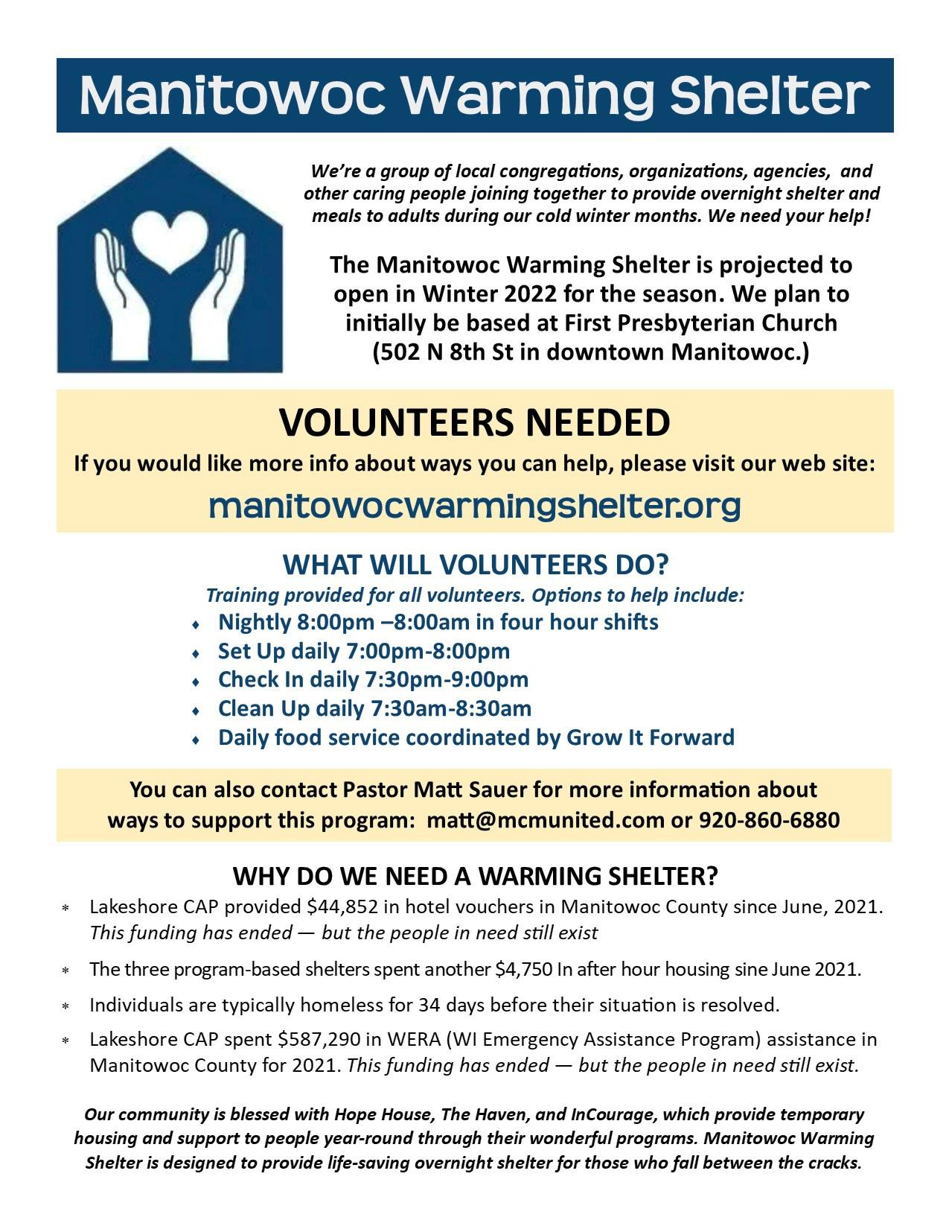

Our Steering Committee will also host Q&A events at 2:00 PM on Sunday, June 26th and at 6:30 PM on Wednesday, June 29th—both events in the upstairs Sanctuary of First Presbyterian Church (502 N 8th St).



The Pantry Press

*Celebrating 39 Years of Service to the Two Rivers-Mishicot Area*

June 2022

**Special Needs for This Month:**

* Jelly
* Baked Beans
* Monetary donations would be appreciated (due to inflation and pantry needs)

**Statistics:**

May 2021 - May 2022

|  |  |
| --- | --- |
| People: | 170 – 155 |
| Families: | 55 – 69 |
| Adults: | 95 – 116 |
| Children: | 07 – 39 |
| New Families: | 02 - 04 |
| Uses Twice: | 09 – 05 |

**Special Thanks:**

LeRoy Denk, Rusty and Diane Walesh, Formrite Companies, local farmers for fresh vegetables and to everyone that did other donations for the month

**Volunteers Needed: We have enough volunteers at this time**

**Food Purchases: No need to purchase food at this time.**

*~*From the ECSW*~*

***Safe Gathering Spaces: Reducing the Risk of Abuse in the Church***

Sunday Evening, June 26th | 7- 8:30 pm | via Zoom

Join in conversation with other leaders for the inaugural SE:aRCh event. It's critically important for every congregation to think through how to make our churches safe spaces for the most vulnerable among us. You may already follow good practices, but are they written down? Are you confident they are up to date? We'll go over the specifics of what should be included in an effective policy, and we'll explore what to do when real-life examples make it hard to follow best practices. Learn from the experts at Crossways Camping Ministries who practice this every day!

As the Executive Director of Crossways Camping Ministries, **Sharon Cook** does more than make s’mores and play guitar (though she can be seen doing both). She has eight years of experience in professional camping ministry, but started with 10 years as a United Methodist pastor serving congregations in Wisconsin. She also spent five years helping United Methodist congregations in Wisconsin develop Safe Sanctuaries policies, and is an experienced and lively trainer.

**Sisters in Christ United for Allyship**

2022 Women of the ECLA Fall Retreat

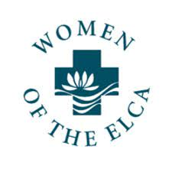“Allyship” will be the theme for the 2022 Fall Retreat on **Saturday, September 24th** at Imago Dei Village. Save the date for this fun filled, inspirational day with engaging speakers and enjoyable music. The keynote speaker will be Bill Van Lopik. Worship with Holy Communion is planned. Bishop Anne Edison-Albright will deliver the message

**Register today** by completing and submitting your registration form (attached as a PDF).  Or register using Eventbrite. (Information for using Eventbrite is located in the registration PDF) You may print forms and share with others in your congregation.

**New this year:**Children ages 6 to 12 can be registered to have a fun day at camp with Imago Dei staff so moms of young children can more easily attend.

**The following is from Pastor Pete Lopez,**

**St John Lutheran Church in Angleton, TX.**

*Be not afraid because we, the ELCA faith community, are in the same boat as other faith denominations. The CV-19 pandemic not only had churches make a sudden shift in evangelism, but it cleared a fog that revealed a cultural change that we didn’t see starting many decades ago. The church has become one group amongst many subcultures in the community. This image illustrates all other groups with which the church has to compete against for your consciousness. It wasn’t always that way. School and community activities stayed away from Sunday morning. Even some stores were closed on Sunday until noon with the exception of a few grocery stores. Many churches and congregants used to believe that all they have to do is keep the lights on and the doors open for the people who will show up. Now we have to be more deliberate about the things we do to bring about an uprising of the gospel. I am not suggesting that we install bouncy castles and flags to get drive-by attention but there will have to be some changes in the way we think and act. Churches are starting to remember a time in history when they were just a small subculture in a larger culture/community.*

*I am writing about the early church during Roman times. Maybe we can take another look at what the early church did to survive and even grow. I like the writings of a Pastor named Brian McLaren. He wrote something inviting readers to imagine what it was like among the disciples gathering together after Jesus’ death. I’m paraphrasing him. He shares that the Apostles were afraid, tense, and questioning their relevance now that their world had changed so much and on top of that, they were afraid to go outside in case someone might recognize them as Jesus’ friends and notify the authorities. What happened on that Friday had been ugly but suddenly, they all felt something, a presence, something familiar yet impossible.*

*He writes “And from that night, we learned something essential about what this uprising is going to be about. This uprising of the gospel isn’t just for brave people, but for scared folks like us who are willing to become brave. It isn’t just for believers, but for doubting folks like Thomas who want to believe in spite of their skepticism. It isn’t just for good people, but for normal, flawed people like you and me and Thomas and Peter; and I should add that it isn’t just for men, either. We have a term for what we began to experience that night: fellowship.*

*Fellowship is a kind of belonging that isn’t based on status, achievement, or gender, but instead is based on a deep belief that everyone matters, everyone is welcome, and everyone is loved, no conditions, and no exceptions. It’s not the kind of belonging you find at the top of the ladder among those who think they are the best, but at the bottom among all the rest, with all the other failures and losers who have either climbed the ladder and fallen, or never gotten up enough gumption to climb in the first place. Whatever else this uprising will become; from that night we’ve known it is an uprising of fellowship, a community where anyone who wants to be part of us will be welcome. Jesus showed us his scars, and we’re starting to realize we don’t have to hide ours; so fellowship is for scarred people, and for scared people, and for people who want to believe but aren’t sure what or how to believe. When we come together just as we are, we begin to rise again, to believe again, to hope again, to live again.”*

*With the help of the Holy Spirit, we will try new things and embark on new journeys. I can’t reveal what the decisions are because I am a pastor and not a prophet. What I can tell you is that we will travel this road together just like the early Christian church that Brian McClaren so perfectly described. God knows we’re scared, tense and questioning our relevance in a world that has changed so much. I truly believe the Holy Spirit has chosen us, bearing all our scars, to bring about all that God has plans for these two churches; in hope again.*

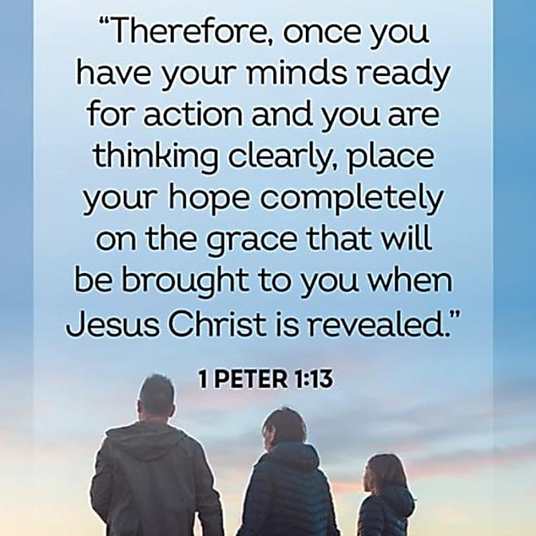

**Council Commentary**

Tuesday, June 14, 2022 - 6 p.m.

**Present:**

Cindy Schmidt, President; Joe Bitto, Vice President; Kim Braun, Secretary;

Diane Grasee and Rita Kreeger

**Secretary’s Report** - Meeting minutes from May 10, 2022 were reviewed and Rita made a motion to approve the May 10th Council Meeting Minutes; seconded by Joe. Motion carried to approve the meeting minutes as printed.

**Statistical Report -** There were no new updates for the Statistical Report.

OLD BUSINESS

**CARELink Report** - The CARELink Statistical Report was distributed which covered the total number of families served from 2020 to May, 2022.

**Employee Reviews** - The Calvary Joint Executive Committee consisting of Cindy, Joe and Kim have completed employee reviews. Cindy, Joe and Kim completed Becky and Darrick’s review and Cindy and Joe completed Jennifer’s review.

**COVID** - Calvary continues to monitor and will take the necessary steps as needed to keep all members and staff safe.

**Gideon’s Presentation** – Al Willems will be presenting a Gideon’s presentation and sermon on July 3rd.

**St. Paul’s Rummage Sale** – St. Paul’s is planning a fall rummage sale. Clothes and other items are requested but no electronics.

NEW BUSINESS

**Joint Executive Committee Meeting** – The May 25, 2022 Joint Executive Committee Meeting minutes were distributed. A meeting is scheduled for Monday, June 20th at 10 a.m. to discuss ways that Calvary and St. Paul’s can work together in planning worship services and acquiring people to provide sermons. Focus is on combining efforts between the two churches.

**Worship Service Schedule** – June 19th with Stan Phelps; June 26th with Pastor Batt; July 3rd with Al Willems from the Gideon’s; July 10th with Stan Phelps; July 17th with Rita Kreeger; July 24th St. Paul’s & Calvary Joint Picnic with Pastor Kim Henning; and July 31st with Pastor Kim Henning. Diane mentioned that Pastor Batt’s worship service went well on Sunday, June 12th with approximately 13-14 people in attendance.

**Baby Shower for InCourage** – Calvary will be collecting baby items through the end of June. There will be a Pack-N-Play set up for items collected in the gathering space.

**Synod Assembly Update** – Cindy provided an update on the Synod Assembly meeting. Discussed at the meeting the sale of the Synod Assembly Building due to working remotely and resolutions passed.

**The Wave Newsletter** – A Gathering Spaces seminar will be held on Sunday, June 26th from 7 p.m. to 8:30 p.m. via Zoom. Seminar focuses on ways to make our churches a safe space for the most vulnerable among us. Leaders from Crossways Camping Ministries will provide their advice and real-life examples they practice every day.

**St. Paul’s Woman’s Retreat** – To be held on October 14 – 15 at Imago Dei.

**Call Committee Update** – Joe Bitto shared with Council that the Call Committee has a candidate to interview for Monday, June 27th via Zoom.

UPCOMING TASKS

**Stewardship Committee Update** – No new updates; committee consists of Joe Bitto, Stan Phelps and new pastor.

**Icon Update** – Lori Williams and Cindy Schmidt plan to go through Icon program to update membership.

There was no further business for discussion and the meeting adjourned at 6:13 p.m. The next scheduled Council Meeting is set for Tuesday, July 12th at 6 p.m. via Zoom. The Zoom meeting link and call-in telephone number will be provided prior to this meeting date along with the agenda and items for discussion.

Kimberly Braun, Calvary Council Secretary

**\*~*Calvary Lutheran’s Worship Service &**

**Helpers Schedule*~\***





**The Calvary Caller**

1921 Adams Street

Two Rivers, WI 54241

**July 2022**

***A family of Christians***

***growing in faith through***

***worship and service.***