**CALVARY CALLER**

October, 2021

Church Office 920-793-3917

Office Hours: 10:30a – 2p

[contactus@calvarytr.org](mailto:contactus@calvarytr.org)

**Pastor Julie Barger**

pastorjuliebarger@gmail.com

**Pastor’s Ponderings-**

Fall is a time where change is displayed in a beautiful array of colors in nature. There’s always sadness to see the warm weather of summer go, but we know it is a cycle of life - so to our comings and goings in our human lives. We welcome a person into our lives and a relationship begins to grow. With time and tending that connection flourishes. Life happens and there comes a time when there is a change in that relationship. From the distance in the relationship there is the sadness of letting go.

We are in a time of transition at Calvary. I am so thankful for this privilege of being your Pastor these past 3 years. Together we negotiated the transition of being a yoked congregation with St. Paul’s. It wasn’t always easy, but this partnership has helped both congregations in many ways. We weathered the first storm of COVID-19 and are navigating this second wave with care.

There are so many people that I have been so blessed to work with in my time here: our church Council for all their support and leadership, the Task Force members for the time and energy they put into our congregation’s well-being during the pandemic, a special appreciation for our Office Manager Jennifer whose dedicated work keeps our congregation connected, for lay leaders and volunteers who faithfully work behind the scenes to keep things running smoothly, and you, beloved members of Calvary who enrich and support our congregation faithfully.

October 10th is my last Sunday leading you in worship. It is a time of transition for us where will we say goodbye to our relationship to Pastor and congregation. Memories of you will forever be in my heart for our time together. Know that synod will be working with you to guide you in this transition. It’s hard not to remember past hurts in transition but we are working to making sure Calvary is supported through the process of calling a new Pastor who will care for you and lead you. We are hopeful for the future so we can grow into relationships with new people that will thrive.

May God’s blessings be with you,

Pastor Julie



**Worship**

With the numbers of COVID-19 cases still being high in our area, we are continuing indoor worship with masks and distancing. We will continue to have shorter worship services without passing of the peace.

The offering will continue to be collected with the offering plate at the back of church or can be sent in the mail.

Communion is our pre-packaged wafer and juice which will be given to you as you enter church; then in the service you will be able to take communion from your seat when directed or bring it home to take at home after worship

.

We will continue to monitor our local conditions and give updates when needed. Thank you so much for your cooperation.

If you have any questions, please contact Pastor Julie or any of the Task Force or Council Members.

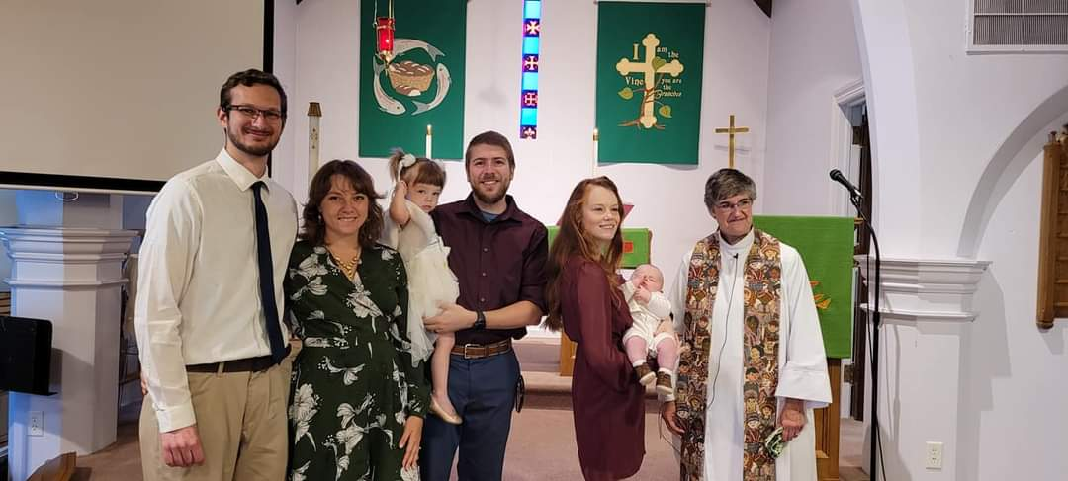

***Congratulations to Isaac Koehl, son of Brian and Quin Koehl and brother of Charlotte. We welcome you to the family of God and our faith community!***

***EDUCATION***

It’s been a busy month! We are so happy to celebrate with Carter and Olivia Gass on their First Communion on Sept. 26th. We hope you will take time to see their projects that helped them share what this faith milestone means to them.

We also celebrate the Affirmation of Baptism – Confirmation for Zachary Whitehouse on Oct. 3rd. Zachary has written his faith statement and will share it with our congregation. With this faith milestone, Zachary will become an adult member of our congregation. Congratulations Zachary!

To help celebrate our time together with me, we have a special activity planned on Wednesday October 6th; we are having fun at Strand Adventures in Manitowoc!

Fun at Strand Adventures - 5-7 p.m. on Oct. 6th. Rock climbing, ninja gym, bounce houses, laser tag and an arcade to explore! For St. Paul and Calvary Sunday School and confirmation families.

$10 per person, sign up with Pastor Julie by Oct. 1st to be included.

(Waiver form needs to be filled out- online). Adults can be a part too!

Sunday October 10th - Children’s Sermon with Pastor Julie at 8:30 a.m. worship

Pastor Julie



**TRANSITION NEWS**:

I have talked with Pastor Asher O'Callaghan, the Synod staff person who is in charge of transitions. He referred our transition leaders to some resources on the Synod website. We will be meeting with him Oct 5th, when we will join with St Paul's council for Pastor Julie's exit interview.

The Joint Executive Committee met Sep 21 to discuss several concerns and how to proceed.

We will need to select people to work on the MSP (Ministry Site Profile) and the call committee.

Services are covered through the end of October. Pastor's last Sunday is Oct 10. Stan Phelps will lead on Oct 17. Rita Kreeger will lead on Oct 24 and 31. The hope is that we will find an interim after that time.

Becky Doyen is expecting her babies in November. She has recorded service music that can be played in her absence. There will also be keyboard help available from Grace on a couple of Sundays in November.

Our Administrative Assistant, Jennifer, is out of the office due to quarantine. We do not know when she will be returning. If anyone is willing and able to help out with office duties, please let me know.

Please pray for all of those involved in this transition process-for guidance, strength, and wisdom.

From Isiah 41:13

"For I, the LORD your God, hold your right hand; it is I who say to you, 'Fear not, I am the one who helps you.'"

Cindy Schmidt, Council President

~~~~

***ANNIVERSARIES***

10/14, Doug & Jean Hoffman

10/18, Adam & Rebecca Doyen

10/14, Darrick & Jennifer Whitehouse

10/25, William& Janice Siewert

***BIRTHDAYS***

10/07, Gwen Hanson

10/11, Darrick Whitehouse

10/12, Rick Jones

10/16, Beth Dow

10/19, Gay Wavrunek

10/21, Brian Koehl

10/26, Sarina Hoffman

10/29, Jerry Wavrunek

10/31, Raven Hinze Meyer

10/31, Marcia Nolan

**The deadline for putting something into the November newsletter is October 15th.**

***In Our Prayers***

In thanksgiving, for Pastor Julie’s time with Calvary. May God continue to bless her in her new assignment.

Bill, Amy, Laurie, Sue, John, Joan, Carol, Margaret, Jane, Louise, Deanna, River, Scott, Melody, Kyle, Richard & Joan, Judah, River, Dave, Bailey, Cannon

We ask that you obtain permission from the person to have their name made public.

Your prayers do make a difference. Thank you, Pastor Julie

**

*During this time of safety at home, prayer requests can be made by emailing the office at* [contactus@calvarytr.org](mailto:contactus@calvarytr.org), *or by calling* *the church and leaving a message for Jennifer or Pastor Julie. In order to include names on our prayer list, we must have the direct and explicit permission of the person involved.*

**January 1st - August 31st 2021**



|  |  |  |
| --- | --- | --- |
| **General Budget (GB)** |  | |
| Income and Expense Report |  | |
| General Fund Income | $58,621.38 | |
| General Fund Expenses | $52,826.89 | |
| General Fund Balance | $5,794.49 | |
| **Capital Improvement Fund** | | | |
| Income and Expense Report | |  | |
| Beginning Balance (Jan 1) | | $13,039.94 | |
| Cap Improvement Income | | $6,696.58 | |
| Expenses | | $8,083.02 | |
| Ending Balance | | $11,653.50 | |



**Council Commentary - September, 2021**

Pastor Julie opened with a prayer. The August 14 Council Meeting Minutes were reviewed and approved as printed. A copy of these Council Meeting Minutes is on file.

**Pastor’s Report** - Pastor reported on the Aug. 29 Joint Worship at Neshotah Park. She reported that she has had some difficulty visiting at nursing homes due to Covid lock-downs.

**Custodian Position** – Darrick Whitehouse has been hired as the church custodian.

**Parking Lot Update** - The parking lot repairs have been completed.

**Joint Worship Service** - Calvary / St. Paul’s Joint Executive Meeting Minutes August 11, 2021 on file. Meeting centered on the Joint Service – Picnic , August 29th at 10 a.m. at Neshotah.

**Extended Ministry Committee** – has put $500 in reserve to donate to the community Christmas dinner if it is held this year.

**Task Force Minutes** - The Task Force Meeting minutes dated September 7, 2021 are on file. Meeting highlights included discussions on the Delta variant and how it affects worship services and building usage. Continued mask wearing indoors in church will continue along with limited seating for safe distancing. Limited amount of singing will also take place. Thursday night services will be recorded. Quilters will be meeting again and will wear masks in building. Blanket Sunday in the month of October will include blankets placed in pews were there are no seated members.

**Finance Update** - The first draft of the budget was distributed to Council members. Final vote will take place during either the October or November Council meeting. A congregational meeting will need to be set up; announcement of such meeting would be communicated two weeks prior to the meeting. We are planning to hold the Congregational Meeting for Sunday, November 14th. A post card would be mailed to members on upcoming meeting.

**Transition** – Pastor’s last day at Calvary will be Oct. 10. The council will be working with Pastor Asher from the Synod to start the transition process. Becky has contacted Grace Church for musical support for November. Volunteers are needed for office duties while Jennifer is out of the office. THERE WILL BE NO THURSDAY NIGHT SERVICES IN OCTOBER.

**Stewardship** – Letters will be mailed out with the 3rd quarter giving statements. A separate letter asking for photos/writings answering “What does God look like?” and or “How have you experienced God’s love?” will be sent out separately in early September. Commitment Sunday will be Oct. 24.

Meeting adjourned 6:43 p.m. Next meeting is Oct. 12, 6:00 p.m.



*\*~\** ***REMEMBER*** *\*~\**

**THERE WILL BE NO THURSDAY NIGHT SERVICES IN OCTOBER**



**The Calvary Caller**

1921 Adams Street

Two Rivers, WI 54241

**October 2021**

***A family of Christians***

***growing in faith through worship and service.***