**CALVARY CALLER**

September, 2021

Church Office 920-793-3917

Office Hours: 10:30a – 2p

[contactus@calvarytr.org](mailto:contactus@calvarytr.org)

**Pastor Julie Barger**

pastorjuliebarger@gmail.com

**Pastor’s Ponderings-**

At Cato Falls recently, I happened to notice something interesting. The river upstream from the waterfall was flowing smoothly when an edge appeared in the water. The water started to glimmer and ripple and within a short distance, it was part of the turbulence of the river heading over the rocks. Most of the time I am looking at the energy of the frothy falls, but it is interesting to focus on that changing point of the river. It makes me wonder about the landscape beneath the surface of the river that causes that change in the water. Does that line ever move or does it always stay in the same place? No matter the answer, the river flows over the rocks continuing its way.

The line in the river before the turbulence of the waterfall reminds me of the time we are in now. There are subtle changes around us that indicate turbulence ahead. Numbers of COVID-19 cases are high right now and we are left wondering what’s in store for us. It seems to me how we face this breaking edge is important. We can worry and be frustrated at why it is happening, but it won’t help because we cannot stop it. Instead, we can do our part to safely navigate the turbulent waters as best we can. We will wear masks and distance along with the other health guidelines knowing that we are the breaking edge of showing Jesus’ love and grace. We will prepare ourselves for the turbulence knowing that this rough time will give way to smooth flowing times once again. May we trust in our everlasting God who will never change.

Peace, Pastor Julie

*“Those of steadfast mind you keep in peace- in peace because they trust in you.*

*Trust in the Lord forever, for in the Lord God you have an everlasting rock.”*

*(Psalm 26:3 & 4)*



**Worship**

With the numbers of COVID-19 cases still being high in our area, we are continuing indoor worship with masks and distancing. We will continue to have shorter worship services without passing of the peace.

The offering will continue to be collected with the offering plate at the back of church or can be sent in the mail.

Communion is our pre-packaged wafer and juice which will be given to you as you enter church; then in the service you will be able to take communion from your seat when directed or bring it home to take at home after worship

.

We will continue to monitor our local conditions and give updates when needed. Thank you so much for your cooperation.

If you have any questions, please contact Pastor Julie or any of the Task Force or Council Members.

September 12th is Rally Day! Come and celebrate another year of Faith Education for our students!  .

TREP TALK

Thank you for the donations for the school supplies.

You can continue to donate through the year ☺



***Welcome to the Staff!***



*We are welcoming Darrick Whitehouse to the staff!*

*‘Hi, my name is Darrick Whitehouse; I’m married to Jennifer Whitehouse and have two boys: Nicholas and Zackary. My family has been members for about 4 years now. I’m also studying at LTC on my off time.*

*Also, I am looking for grants and/or sponsors for a hand cycle or recumbent bike as I can get back into biking.* *This kind of bike would work well with my leg prosthetics.’*

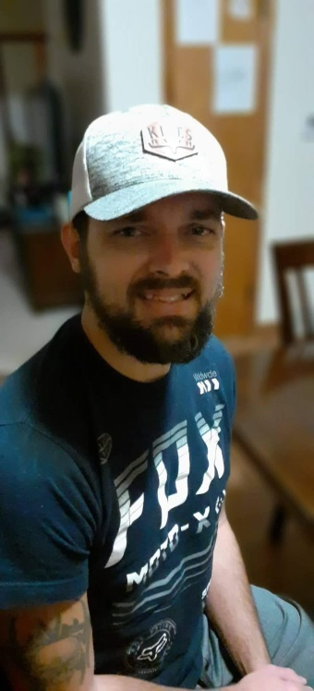

~~~~

***ANNIVERSARIES***

09/10, Jim & Lori Williams

09/27, Rick & Kay Wirrer

09/29, Cass & Lisa Shimanek

***BIRTHDAYS***

09/08, Kay Puls

09/05, Cynthia Phelps

09/07, Charlotte Koehl

09/08, Kay Puls

09/16, Roxanne Spiering

09/19, Mark Gass

***Education & Youth***

**Sept. 12th -** **Rally Day-** **Worship at 8:30 a.m.**

We invite children and youth to bring their backpacks for a special blessing in worship and a treat.

We are excited about a new year of faith education for our children and youth!

More plans for family faith and fun for this fall coming up so stay tuned for more information.

Blessings, Pastor Julie

Weekly Text Study continues for Calvary and St. Paul on Monday mornings at 10:30 a.m. We meet in-person with masks at St. Paul but also have a ZOOM link to participate online. If you can’t make it every week that’s okay; each week, we look at the texts for the week, particularly the Gospel for the next Sunday and share thoughts about the passage. We share commentaries and wonder more about faith in our lives. Come and join us!

***In Our Prayers***

In thanksgiving, for a safe and successful transition back to school for our students, families, and staff.

Bill, Amy, Laurie, Sue, John, Joan, Carol, Margaret, Jane, Louise, Deanna, River, Scott, Melody, Kyle, Richard & Joan, Judah, River, Dave, Bailey, Cannon

We ask that you obtain permission from the person to have their name made public.

Your prayers do make a difference. Thank you, Pastor Julie

**

*During this time of safety at home, prayer requests can be made by emailing the office at* [contactus@calvarytr.org](mailto:contactus@calvarytr.org), *or by calling* *the church and leaving a message for Jennifer or Pastor Julie.*

*In order to include names on our prayer list, we must have the direct and explicit permission of the person involved.*

**The deadline for putting something into the October newsletter is September 15th.**

**Council Commentary - August 10, 2021**

Pastor Julie opened the meeting with a reading taken from Friedman’s Fables entitled, “The Bridge” -- Rabbi Edwin Friedman’s fable of breaking free from codependency. Each of us has a position of choice in life. We decide how it ends.

The July 13th Council Meeting Minutes were reviewed and approved as printed. A copy of these Council Meeting Minutes are on file.

**Pastor’s Report** - Pastor Julie attended a Synod online meeting about Youth & Education which provided some helpful ideas and resources to engage in faith education in the first third of life. Pastor shared this website with the Youth & Education Committee. Rally day is planned for September 12th. A celebration after worship is also planned as long as COVID-19 cases remain low. This would be an outdoors celebration and masks would be encouraged since children are not able to be vaccinated.

**Security Committee** - Joe Bitto is testing new doorbell system. This new system will need to have an Ethernet wire run. There is currently a long delay in getting the video. This is a work in progress.

**Custodian Position** - Two candidates have interviewed for the custodian position with the Joint Executive Committee. Bonnie Bitto has been keeping the church clean during this transitional period. Once a new custodian is hired, Bonnie will provided training.

**Parking Lot Update** - The parking lot repairs will be completed by Monday,

August 16th.

**Task Force Committee** - Bishop met with pastors and encouraged them to consider the WI Council of Churches latest update, “By Faith We Stand Firm.” The update encourages the use of masks for everyone vaccinated and unvaccinated when worshipping in church. Rita Kreeger made a motion to follow the Task Force recommendation to have mandatory mask wearing for in-person worship and to suspend fellowship time. Motion 2nd by Barb Jensen. All in favor & motion passed.

**Joint Worship Service** - The Joint Church Service is scheduled for Sunday, August 29th at Neshotah beach. Calvary and St. Paul’s Joint Executive Committee is planning to hold a meeting on Wednesday, August 11th to discuss the details of this event further.

**Correspondence Update** - Received a request from the ELCA World Hunger for support on programs that the ELCA provides to help people facing hunger and poverty. Pastor also shared with Council a thank you received from the Locke family.

**Extended Ministry Committee** - received a request for $500 from TREP.

**Thursday Night Worship (COVID)** - Council discussed with the rise in COVID cases, how this may affect Thursday night worship services. We are looking at lay leaders who are willing to do the worship services with a limited amount of people. Recording the services is always an alternative.

Meeting adjourned with the Lord’s Prayer at 6:51 p.m. Next Council Meeting is scheduled via Zoom on Tuesday, September 14th at 6 p.m.

Respectfully submitted, Kimberly Braun, Calvary Council Secretary

*\*~\** ***ANNOUNCEMENT*** *\*~\**

I am engaged to be married to a wonderful man, Mike, from Kewaunee. We plan to be married next year. I am very happy. I do not exactly know what this means for the future, but I will keep you informed.

Thank you for your support and leadership.

Pastor Julie



**The Calvary Caller**

1921 Adams Street

Two Rivers, WI 54241

**September 2021**

***A family of Christians***

***growing in faith through worship and service.***