**CALVARY CALLER**

June, 2021

Church Office 920-793-3917

Office Hours: 10:30a – 2p

[contactus@calvarytr.org](mailto:contactus@calvarytr.org)

**Pastor Julie Barger**

pastorjuliebarger@gmail.com

**Pastor’s Ponderings-**

This year’s assembly for the East Central Synod of WI was held virtually May 14-15. Out theme was God in the Empty Spaces *“…to bring rain on a land where no one lives, on the desert, which is empty of human life…” Job 38:26.* Our keynote speaker Anna M. Madsen helped to think about this passage of Job and what it might mean for our lives today. Anna related to the times we are in as a paradox of empty and full. I related to that because we felt so isolated during the pandemic and now coming back together seems so joyful but sometimes it can feel like a lot all at once! But we also know that there are no empty spaces - even if it seems like there isn’t human activity, often there is a lot going on in God’s creation. The desert places are in fact teeming with life if you know where to look and when. God is the creator of life and the center of the universe, not us. This occurs in times of our lives when things are happening even if we can’t seem them. We were reminded by Bishop Anne that there are no God-forsaken places and no God-forsaken people! Our delegates and our congregation were given a copy of Anna Madsen’s book “*I Can Do No Other: The Church’s New Here We Stand Moment*.” Let me know if you’re interested on reading it.

Synod assembly had its usual share of business to complete with reports of the past year and financial information to share. Elections were held to fill synod council and other roles. I was nominated and elected to serve as a rostered leader delegate for Church wide Assembly in Ohio next summer in 2022. I am looking forward to learning more about what’s happening at the ELCA at the national level and sharing that with you when I return.

Resolutions introduced and approved by the assembly were on areas to learn about and discuss in our congregations; hunger, LGBTQ+ and anti-racism. There are many resources to help us understand what it means to share the love and grace of Jesus inclusively. We may not agree but starting the conversations are essential to understanding one another.

Rev. Asher O’Callaghan was installed on a special service on Sunday May 16 as the Associate to the Bishop in charge of Transitions and Mobility. We look forward to working with Bishop Anne, Pastor Asher and the rest of the synod staff. Please keep them in your prayers. Even though we were attending virtually for this synod assembly, I am glad I could attend and learn more about what’s happening at our synod and church wide levels of the ELCA. See me if you’d like more information on any of this synod assembly. - Blessings, Pastor Julie -



**Worship**

As more of our community is vaccinated and the numbers of cases of COVID-19 remain low, our task force is adjusting how we gather safely.

*\*\*\*Our council has approved a new plan for worship starting in June with Thursday night worship at 6:30 p.m. As part of our yoking with St. Paul, I am at Calvary on the 2nd and 4th Thursdays of the month, and we will have lay leaders on the 1st and 3rd Thursdays of the month. \*\*\**

I am so grateful to the talented lay leaders we have at Calvary who lead worship faithfully. With this plan, Thursdays will help to balance out numbers between the days and meet people’s schedules better. Our Sunday mornings will continue at 8:30 am with no pre-registration.

We thank you for continuing to wear masks and to distance when necessary for both services. With this add of Thursday night worship, we need a few more people to help with ushering, lecturing, altar guild, etc. We would like a person to help record the service on Thursday nights so it will be available to watch Sunday mornings for those who cannot attend.

We are so thankful to Joe Bitto for all his work recording worship over these past many months. He needs a vacation! Please see me or Jennifer if you can help in any of these ways. See any of the task force members if you have questions or input. We thank you for your cooperation!

**Thank you to the Task Force**

Our task force members have worked diligently this past year to help our congregation made decisions with the COVID-19 restrictions. They have researched medical information as well as recommendations from the CDC and WI Council of Churches. We have spent time and energy in setting up plans so that our members would be able to worship in the safest way for our situation.

We know that our plans were not the same as other churches, but we appreciate your support in knowing that the task force had our members’ best interests at heart. These decisions have not been made lightly. The task force has been a very crucial part of problem-solving and leadership resiliency that has been so important to my leadership as your Pastor.

Please express gratitude to the members of the task force with me; Joe Bitto, Becky Doyen, Brian Jensen, Rita Kreeger, Stan Phelps, and Cindy Schmidt. Well done good and faithful servants!

Pastor Julie

CONFIRMATION STUDENTS

Stay tuned for Confirmation camp pictures!

**Bible Study Update**

Adult education continues with the weekly text study email every week and a ZOOM and in person discussion on Monday mornings at 10:30 a.m.; at St. Paul.

See Pastor Julie for more details.

*The mortgage burning celebration is on June 6th, and June 13th as the rain date. Help us celebrate the "Sweet" success of paying off our mortgage early with the help of our generous donors. Join us for cake and fellowship outside after worship!*



~Family, Faith, Education~

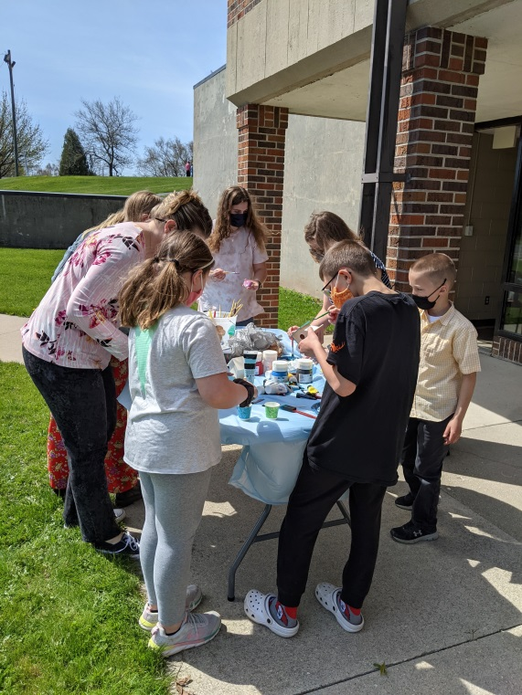

Sunday School students from St. Paul and Calvary were invited to make Mother's Day gifts on a Sunday after worship, so glad our confirmation student Zachary Whitehouse helped out. He's great at kickball too!

*Here is a thank you note from a ministry we support – this is from Foundations, which used to be RAYS*

“Thank you for your thoughtfulness sand generosity. We received the March benevolence gift from Calvary Lutheran Church. Thank you for changing the lives of runaway and homeless youth in Sheboygan! You are part of the Solution!...”

~~~~

***ANNIVERSARIES***

06/07, Bill & Pat Gilbert

06/11, Charlie & Cheryl Philipps

06/19, Steve & Sara Laurin

06/26, Joe & Bonny Bitto

***BIRTHDAYS***

06/01, Ben Dow

06/02, Patricia Gilbert

06/03, Tristyn Mathiesen

06/03, Nancy Welter

06/05, Benten Dow

06/05, Bev Schmidt

06/09, Nancy Klinkner

06/09 William Siewert

06/13, Hannah Shimanek

06/15, Lisa Shimanek

06/20, Morgan Arneman

06/26, James Parker

06/29, Ana Peduk

06/29, Lori Williams

I apologize – the original printed version for May’s Caller had Jackie Siebert’s namespelled incorrectly.

*If you have a graduate in your family we would love you to send in your graduate’s pictures so that way we can celebrate with them!*

**~~~~**

***In Our Prayers***

In thanksgiving for Father’s Day and those who do fatherly things.

Blessings for those who are graduating and finishing school.

Bill, Amy, Laurie, Sue, John, Joan, Carol, Jeff, Margaret, Jane, Louise, Deanna, Judah, George, River, Darrick.

We ask that you obtain permission from the person to have their name made public.

Your prayers do make a difference. Thank you, Pastor Julie

**

*During this time of safety at home, prayer requests can be made by emailing the office at* [contactus@calvarytr.org](mailto:contactus@calvarytr.org), *or by calling* *the church and leaving a message for Jennifer or Pastor Julie.*

*In order to include names on our prayer list, we must have the direct and explicit permission of the person involved.*

**The deadline for putting something into the July newsletter is June 15.**

**COUNCIL COMMENTARY - May 11, 2021**

Pastor Julie opened the meeting with a Care for Creation devotional taken from the Stewardship Lutheran School of Theology in Chicago, Illinois on the issue of world hunger. All of us can do our part in helping to eliminate world hunger by being more generous with our abundance of gifts.

Pastor’s Report touched on how this was a month of transition going from pre-recorded services to in-person worship services. Worship services will continue to be videotaped for those who are unable to attend in person. Pastor has been making more visits in person. Confirmation students have met two times for in-person classes already.

Pew envelopes have been updated to include CARELink as a benevolence offering. An upcoming Newsletter article will be published to members on what CARELink is and how anyone can contribute to this program.

Security Committee is looking at a doorbell system for front church doors. The system is for people looking to gain access into the church building. Doors remain locked at all times.

Pastor Julie will be attending the Synod Assembly May 14th and 15th.

Council has decided not to hold a rummage sale this year due to lack of volunteers needed to set up and clean up.

Council is reviewing a time frame to hold their annual retreat.

Task Force Committee’s next meeting is scheduled for May 24th. Scheduled meetings going forward would be held on an “as needed” basis with the continued monitoring of COVID.

The Joint Executive Committee Meeting met on April 28th and meeting minutes are on file.

Spring work day at Calvary is scheduled for Saturday, May 15th and Saturday, May 22nd from 10 a.m. to 12 p.m. Rain date is June 13th.

Pastor Julie will include in upcoming Newsletter, an article requesting input from congregation on ideas they may have that congregation could work towards a new goal now that the mortgage for the building has been paid off.

Pastor Julie and Council discussed getting confirmation kids more involved in church by having them share their spiritual gifts/interests in areas that they would like to serve within the church. Pastor Julie would also like to see a mentor assigned to kids who would have similar interests.

Council has approved holding Thursday night worship services starting in June.

An e-mail will be sent out to members requesting names of those students graduating from high school or college so that they may be honored for their endeavors.

Meeting adjourned at 7:02 p.m. with the Lord’s Prayer. Next meeting is scheduled for Tuesday, June 8th at 6 p.m.

Respectfully submitted,

Kimberly A. Braun

Calvary Church Council Secretary

**January 1 - April 30, 2021**

|  |  |  |  |  |
| --- | --- | --- | --- | --- |
| **General Budget (GB)** |  |  | **Capital Improvement Fund** |  |
| Income and Expense Report |  |  | Income and Expense Report |  |
| General Fund Income | $31,834.97 |  | Beginning Balance (Jan 1) | $13,039.94 |
| General Fund Expenses | $27,742.86 |  | Cap Improvement Income | $3,137.74 |
| General Fund Balance | $4,092.11 |  | Expenses | $897.25 |
|  |  |  | Ending Balance | $15,280.43 |



***MINISTRY UPDATE***

The Worship team is starting to “stock” the pews again - you will notice that hymnals are back for your use if desired.

You will also notice new donation envelopes in the pew pockets.  These may be used when:  
 *you want to make a special donation  
 *you are in need of an envelope for your regular tithing  
 *a visitor would like to make a donation

Write your name, envelope number (if you know it), the total amount enclosed and how much of that amount you want to go to whichever designation(s) you choose. The list includes: Calvary (General or Maintenance Fund), Two Rivers Ecumenical Pantry, Quilters/Blanket Sunday, CARE-link, Lutheran World Relief and Other (for Hope House, Habitat for Humanity, Gideons or any special collections by Calvary)

*\*\*Just a little more about CARELink- it is a program to help people in need in our area. It was formed by our ecumenical group of Manitowoc County. \*\**

These groups of congregations, including different denominations, are working together too financially and prayerfully support this ministry. The CARELink program is operated through the Salvation Army which already has the resources to offer basic needs with job counseling and other support to help people become self-sustaining. The help offered is much more than our congregation could do alone and has helped cut back on people frequently asking for help from many congregations. With the congregations who participate in this program, CARELink have been able to help individuals and families with rent, utilities, transportation costs and other basic needs.  From the donations of over $35,000 from the beginning of this program, the balance is now under $14,000. Calvary supports this program with our benevolence in offerings but any help you can add would be appreciated to sustain this valuable ministry. See Pastor Julie if you would like more information.

**The Calvary Caller**

1921 Adams Street

Two Rivers, WI 54241

**June 2021**

***A family of Christians***

***growing in faith through worship and service.***