**CALVARY CALLER**

September 2019

Church Office 920-793-3917

Office hours 10:00 a.m. – 2:30 p.m.

[contactus@calvarytr.org](mailto:contactus@calvarytr.org)

**Pastor Julie Barger**

pastorjuliebarger@gmail.com

# **Pastor’s Ponderings-**

As I write this article, I am preparing to leave on vacation with my family. I am so looking forward to spending time with four out of my five siblings and my mom. Since we are spread out across the United States, we don’t get to see each other often. So, when we can get together as a group and spend time together, it’s special. When we are together, I notice that we each have our individual personalities with our own thoughts and ideas. It takes respectful communication to listen and talk so we understand each other’s viewpoints. When we have differing opinions, it’s important to know that we can still be in respectful conversation, even if we disagree.

It’s true for us as Christians as well. We are part of the family of believers in our congregation, our community, our synod, our country and the world. We have a unique connection in Christ that includes people of different denominations, races, cultures and perspectives. We certainly have things that we disagree about, but we can still be in respectful conversation with one another. We can understand that our perspectives are based on our own thoughts, feelings and experiences. When we disagree, we can ask questions and listen to why the other person thinks the way they do. We don’t need to be defensive or judge, we can simply understand how that person got to their opinion. Then we can calmly share our perspective and how we got to this viewpoint based on our own experiences.

Other times, the information solidifies the opinion I had all along. With respectful communication, people are able to stay in relationship with one another, even if they disagree on certain issues.

One of the best visuals I learned for thinking about disagreements and problems is a tug of rope competition. In a traditional tug of war, each side is pitted against each other and one side will win and one will lose. Name calling and blaming others are ways that people fight against each other. They never lead to resolution, only hatred and division. Instead of a competition, think of the tug of war being you and I working together against a problem. We may have different perspectives about how to solve that problem, but by working together we can problem solve to reach a solution. Sometimes a creative brainstorming of different perspectives can lead to solving the problem effectively in unexpected ways. It is important for us to be open to possibilities that God is working amongst us in relationship. I am so glad I am on Christ’s team with you pulling against life’s problems!

Stay strong,

Pastor Julie

Listening to another person’s perspective has sometimes helped me to think differently because I had new information that helped me reframe my perspective.

**Rally Sunday September 8**

Rally Sunday is a day for ALL of our members to gather together to celebrate the kick off of all our fall education activities.

**Blessing of the Backpacks**

*For students and teachers of ALL ages!*

Students, preschool through adult, are invited to bring their school backpacks to worship on Sunday September 8 for a special blessing for the beginning of a new school year.

The backpack blessing is a way to bless part of the students’ everyday lives to connect Sunday and the rest of the week. A gift will be given to each student for their backpack which will be a daily reminder of their church family praying for them and of God’s presence in our daily lives.

**Rally Day Social**

Following our 8:30 a.m. worship, the congregation is invited to stay for a social time in the Gathering space for refreshments.

Our 75th Anniversary

**Sunday, September 15, 2019 is the date of our celebration.**

Celebrating 75 years of ministry and worship, our Sunday service of Holy Communion will be at 10:30 am (not 8:30 am) with the Bishop leading worship just for this occasion. It will be followed by a dinner and program at noon. Invitations are out and the deadline to RSVP is Sept. 3rd, so we can have anaccurate head count.

[To RSVP contact Calvary by phone, mail, or email.](mailto: To RSVP contact Calvary by phone, mail, or email.920-793-3917contactus@calvarytr.org)

[920-793-3917](mailto: To RSVP contact Calvary by phone, mail, or email.920-793-3917contactus@calvarytr.org)

[contactus@calvarytr.org](mailto: To RSVP contact Calvary by phone, mail, or email.920-793-3917contactus@calvarytr.org)

If you have a special life memory that took place at Calvary, or if you would like to donate to the anniversary celebration fund, please drop it into the box designated 75th Anniversary in the Gathering Space or bring a hard copy of your memory to the office. Donations help to pay for the cost of food. We are so looking forward to this special day in our legacy of faith- we hope you will come join us!

Education News

**Sunday School Families**

We are working on a schedule for our Sunday School classes this fall. We have a meeting on Monday August 26 at 6:30 p.m. at Calvary to plan our year.

**Confirmation**

Our confirmation classes are gearing up for another faith-filled year! We will begin with a **Family** **meeting** **on Wednesday September 11 at 6 p.m. at St. Paul.** We willhave a light meal for 7th & 8th grade students and their parents from St. Paul and Calvary. At this meeting, we will discuss confirmation and establish the schedule and expectations for the year.

Confirmation classes will then continue for students each Wednesday from 6- 7 :15 p.m. and we will alternate locations between our congregations. More info with be shared at the meeting.

***Newsletter deadline for October’s issue is September 18.***

Please pray for our confirmation students and their families as they progress in their faith formation.

****In thanksgiving for.**

***In Our Prayers***

**For healing,** especially for **Jerry,** **Stan**, **Carol**, **Jackie**, **Marcia**, **Diane**, **George**, **Kristy**, **Daryl**, **Don**, **Joanne**, **Arnie**, **Amy,** and **Darrick**.

**For those with cancer**, especially **Wes** and **Alex**.

**For those with chronic illness** and have asked for prayer: **Richard**, **Tina**, **Carrie**, **Scott**, **Debra**, **Sandra**, **Theo**, and **Kyle**.

**For those in the military**, especially **Dawn**, **Benjamin**, **Peter,** and **Chad.**

**For those in care facilities** or living with assistance, especially**, Nancy, Shirley, Helen**, **and Gail.**

**We mourn** with those who have lost a loved one in the last month, especially the families and friends of **Don Jaeger, Karl Pasch, & Chris Decker.**

*Prayer requests can be made by filling out the form on the Prayer Ministry table in the Gathering Space or by talking to Pastor Julie.*

*In order to include names on our prayer list, we must have the direct and explicit permission of the person involved.*



***Anniversaries***

**Rummage Sale Results**

The Annual Rummage Sale brought in $2282. We thank everyone who donated time, help, bakery, and items to sell. We especially give kudos to Sue Becker, who once again organized and planned the event and without whom we might not have these additional funds each year!

**T.R.E.P. Emergency!!**

T.R.E.P. is in desperate financial need. We are not getting financial assistance from our supporting congregations, industries, or businesses. If the pantry doesn’t get help, it will have to close by the end of the year!

Many of TREP’s clients are elderly who can’t afford food because of the cost of medication or they have to raise their grandchildren because their children are unable to parent as the result of addictions. The pantry will be holding two fundraisers this Fall, a brat fry and a spaghetti supper, but they still need financial help.

Please help TREP! Our community needs the pantry more than ever.

**Grief Share Support Group Sept. 4 – Nov. 27**

This is a 13 week support group with video, small group discussion, and personal workbook exercises with multiple topics such as: Is This Normal? and The Challenges of Grief.

GriefShare uses a biblical approach to deal with grief and each session is self-contained so that anyone can choose to come to one or all sessions, beginning at any point in the series.

Sessions begin Wed. Sept. 4, from 6pm – 8pm at St. John Evangelical Lutheran Church 14311 Maribel Rd. Maribel, WI. There is no charge for this program. For more information call: 920-973-0828 or go to: [www.griefshare.org](http://www.griefshare.org).

**New Bible Study**

Starting in September, Rev. Bruce Hanstedt will lead a fall bible study on Monday evenings at St. Paul starting Sept. 23. There will be more info to come.

The weekly text study held at the library all summer will move back to St. Paul on Monday mornings starting Sept. 9.  Note: Sept. 2 is Labor Day so there will be no study that day. The time we meet will be changed- we are going to try a study on Mondays 11:30 a.m- 12:30 p.m. so perhaps people will be able to attend on their lunch break. Please being your lunch to eat if you would like- I know I will!

**Women of the ELCA**

WoELCA, East Central Synod are looking to connect with women in all congregation. There will be a Fall Retreat on September 20-21, 2019, at Imago Dei Village Bible Camp near Clintonville. Enjoy fellowship in a beautiful setting as we grow in faith and worship together. Speaker Kay Zastrow is featured. Her topic is, “Unity of the Spirit: We Are All in This Together!” based on Ephesians 4:3. You may register for the whole retreat or Friday evening/Saturday separately. Scholarships are available. FMI contact Carol Cleveland at [cacleveland50@gmail.com](mailto:cacleveland50@gmail.com)

**Night of Hope**

**Substance Abuse Vigil**

**Sept. 22**

Calvary church will join other area Christian communities and non-profit groups for a “Night of Hope” starting at 7pm on Sunday, Sept.22. Participants will gather at the Farmer’s Market Lot on the corner of 8th St. and Quay St. and are encouraged to wear purple in awareness of substance abuse.

Everybody is invited to decorate a luminary in honor/memory of a loved one or for general awareness of substance abuse. Bags and materials for luminaries will be available in the Gathering Space. We invite you to make a luminary and bring it to the event with you. Ride sharing to the event may be possible. Pastor Julie will have more information closer to the event.

Ollie Press was last month’s winner from the earth friendly drawing. This was the last drawing, and while Calvary may not be giving out prizes, we must still remember that we are the stewards of God’s Creation.

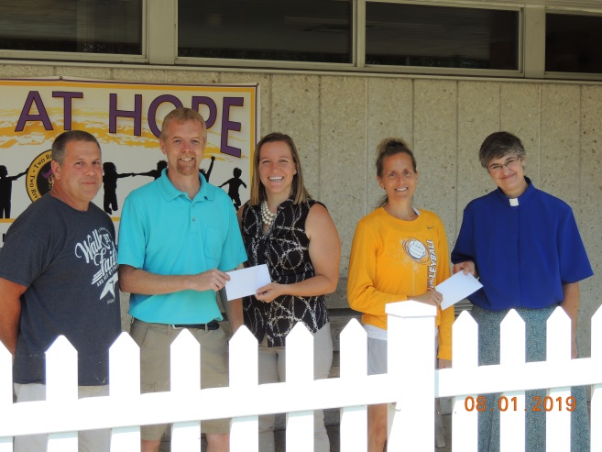

Members of Two Rivers Ecumenical Ministries make donations to Two Rivers’ Schools.

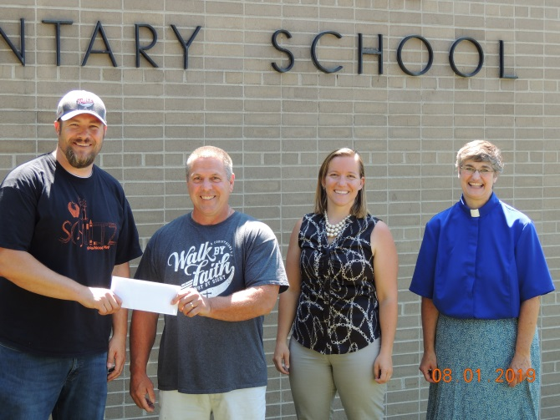

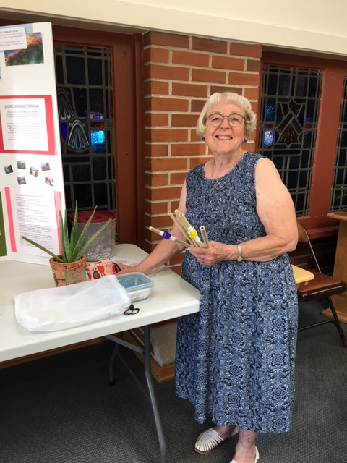

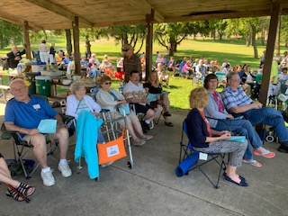

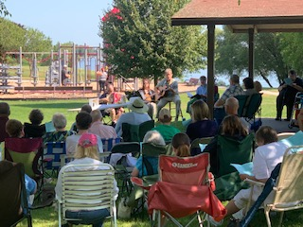



I would like to thank everyone who organized the church picnic at Red Arrow Park. It was so well organized; the church service was so good. I hope we do it again next year.

-Caroline Curtis

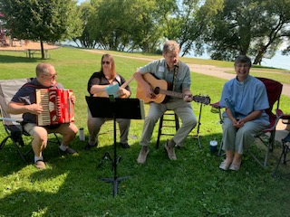 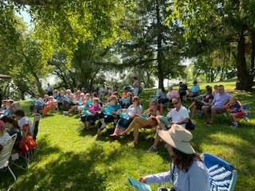

**Calvary and St. Paul Lutheran Churches join in Red Arrow Park for outdoor worship and picnic.**

|  |  |  |  |  |  |  |
| --- | --- | --- | --- | --- | --- | --- |
| **September 2019** | | | | | | |
| Sunday | Monday | Tuesday | Wednesday | Thursday | Friday | Saturday |
| **1** | **2 Office Closed**  **For Labor Day**  7:00 pm AA | **3**  7:00 pm NA | **4**  7:00 pm AA | **5**  **6:30 pm Worship**  7:00 pm Al-Anon | **6** | **7**  6:00 pm AA |
| **8**  **Rally Day**  **8:30 am Worship w/ Communion**  9:30 am Fellowship | **9**  7:00 pm AA | **10**  **Quilters 9-11am**  **6:00 pm Council Meets**  7:00 pm NA | **11**  **6:00pm Confirmation Family meeting @ St. Paul**  7:00 pm AA | **12**  **5:30 pm Calvary Kids**  **6:30 pm Worship w/ Communion**  7:00 pm Al-Anon | **13** | **14**  6:00 pm AA |
| **15**  **75th Anniversary Celebration**  **10:30 am Worship w/ Communion**  12 pm Diner Program | **16**  7:00 pm AA | **17**  **Quilters 9-11am**  **6:00pm Finance Com.**  7:00 pm NA | **18**  **Newsletter Deadline**  **6:00pm Confirmation @ St. Paul**  7:00 pm AA | **19**  **6:30 pm Worship**  7:00 pm Al-Anon | **20** | **21**  6:00 pm AA |
| **22**  **8:30 am Worship w/ Communion**  9:30 am Fellowship | **23**  7:00 pm AA | **24**  **Quilters 9-11am**  7:00 pm NA | **25**  **6:00pm Confirmation @ St. Paul**  7:00 pm AA | **26**  **6:30 pm Worship w/ Communion**  7:00 pm Al-Anon | **27** | **28**  6:00 pm AA |
| **29**  **8:30 am Worship w/ Communion**  9:30 am Fellowship | **30**  7:00 pm AA |  |  |  |  |  |

**Council Commentary**

The August Council meeting began with a reading from the text, “My Heart is Ready”. In this reading, we are reminded of “Our Holy Mountain”. Each of us have such a special place where we experience wholeness and rebirth. We give thanks to God as the giver of the beauty that surrounds us.

Pastor Julie’s Council report outlined our engagement with the recovery community. This continues to be an area of emphasis for CLC. Activities over the past month included a visit to the Lighthouse Recovery Center and attendance at Drug Court. Both are key components in the process of rebuilding lives by providing a safe/positive/supportive place for gathering while holding individuals accountable for their actions. Items from the CLC rummage sale were provided for use in this rebuilding process. Future use of Extended Ministry funds in support of this community will be explored. TREM received our designated Lenten offering for use in meeting the needs of families. Leaders of the ecumenical community recently met with area school principals to explore areas of cooperation. This has been an area of engagement with CLC with collections continuing for back to school supplies.

The decision was made to focus on joint service projects with St. Paul over the next year. The first of these would be to work with St. Paul in providing a Manitowoc community meal in October. These are held on the 2nd and 3rd Wednesdays of each month. Similar plans would be developed to host a Sunday Supper in the new year inviting St. Paul to work with us. Both projects use well-developed procedures and provide the opportunity to work in tandem meeting a community need for food and fellowship. These are stepping stones evidencing our progression towards shared ministry with St. Paul.

The opportunity for participating in our Synod’s relationship with the Evangelical Lutheran Church In Southern Africa was outlined. A commitment has been extended to host two individuals from our companion parish in early summer 2020.

Finally, plans for the 75th Anniversary celebration of CLC on September 15th were shared with Council. RSVPs are needed ASAP. Please plan on attending and celebrating this important event in the life of our congregation!

-Brian Jensen

