CALVARY CALLER

August 2019
Church Office 920-793-3917
Office hours 10:00 a.m. – 2:30 p.m.
contactus@calvarytr.org
Pastor Julie Barger
pastorjuliebarger@gmail.com

Pastor’s Ponderings
Sunny summer days are here and there’s so much in our community to enjoy. Concerts, parades, and many outdoor activities abound in the summer. What blessings we have here in our area with the beautiful lakeshore, good food and fun! Other people want to share in this blessing and come as tourists, guests in our midst. We know that our local economy depends on the visitors to the area, but there are other benefits that we can consider. People from different places bring new ideas and experiences. They connect us to a larger world and stretch our connections beyond our area. As inclusive people of faith, we are “ambassadors of respect” to those who visit. We are open to people from other places by being friendly with an accepting attitude for people of varied backgrounds and cultures.
As citizens of our community, our welcoming attitude can make such a difference for people who visit. Being friendly means, we greet people warmly and show an interest in them. We can ask questions in a positive manner that help us connect. It is interesting to find out the connections we have to people in other places. A friendly and positive connection means we take our cues from the people we are talking to- if they are not interested in conversing much, we can welcome them simply without overwhelming them.
Having more people to contend with means sharing what we have and showing patience with people who aren’t familiar with this area. Sure, sometimes it’s hard when parking spaces are few or traffic is busy, but I look at it this way- we are blessed with a beautiful area that people want to come and be a part of! As we are so generously blessed by God, we share with others knowing that this beauty is for all.
Blessed to be a blessing!
Pastor Julie
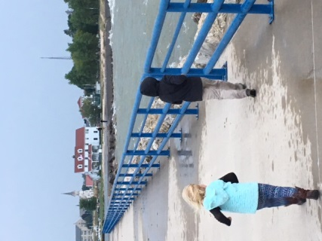

Vacation Garden Bible School
VBS is taking registrations from children in grades pre-K through 6th. Sponsored by St. Paul Lutheran, Calvary Lutheran, St. John’s UCC, First Reformed ICC, & First Presbyterian Churches, registration is open to any child, at no cost.
The event is one day – Wednesday, August 28th. Check in and introductions are from 12:30 – 1pm with the classes beginning at 1pm until 5 pm at which time the families of students are invited to join teachers and students for a free community dinner.
We’ve got lots of activities to engage and learn in faith and fun! As part of our hands-on service, we’ll be preparing a delicious salad for the Community Dinner.
Everything is held at First Presbyterian Church, 502 N. 8th St. in Manitowoc. Registration forms are available in the Calvary Gathering Space.

Joint Outdoor Worship!
Calvary and St. Paul Lutheran Churches will be Worshiping together on August 4th in Red Arrow Park at 10 am. This outdoor service will replace the usual Sunday service at both churches. We will be at an open-air shelter overlooking the beautiful Lake Michigan shoreline – a wonderful way to emphasize God’s abundant goodness in creation! There’s plenty of shade and plenty of space so bring your chairs. Our worship readings and music will be emphasizing the creation covenant given by God in Genesis to be caretakers of the earth. Special thanks to Dan Johnson for helping to plan and co-lead this worship. We will collect an offering and we will have communion.
After the worship service, we will have a potluck meal. We will be providing sandwiches and water and lemonade, as well as plates, napkins and utensils. We have a sign-up sheet to bring either salads or desserts. Please note there is no electricity at our site so there will be no way of keeping things plugged in. After our potluck, we can enjoy talking or walking on the beach- parents please note there is no lifeguard in this area, so all children will need to be supervised by the water. We will also have some yard games and bingo. Thank you to Thrivent for providing an action team grant for this event and the planning committee for organizing this event. We hope you’ll join us for food, faith, fellowship and fun!
Rain place is St. Paul, 2601 S. 10th Street in Manitowoc.
Our 75th Anniversary
Sunday, September 15, 2019 is the date of our celebration.
Celebrating 75 years of ministry and worship, our Sunday service of Holy Communion will be at 10:30 am (not 8:30 am) with the Bishop leading worship just for this occasion. It will be followed by a dinner and program at noon. Invitations are out and the deadline to RSVP is Sept. 3^{rd,} so we can have an accurate head count.

To RSVP contact Calvary by phone, mail, or email.
920-793-3917
contactus@calvarytr.org
If you have a special life memory that took place at Calvary, or if you would like to donate to the anniversary celebration fund, please drop it into the box designated 75th Anniversary in the Gathering Space or bring a hard copy of your memory to the office. Donations help to pay for the cost of food. We are so looking forward to this special day in our legacy of faith- we hope you will come join us!

Please Be Aware
The Milk Moola Program has ended, and while Box Tops for Education is still running, the program is not collecting the actual box tops anymore. They are now using a digital program. If you are still interested in participating, please contact your local school to see what they are doing. Thank you to those who have collected box tops and Milk Moola items over the years. Your support is greatly appreciated.

Newsletter deadline for September’s issue is August 18.

Gospel Music Fest 2019
Grab your lawn chairs and come
for this wonderful weekend of music!

Friday, August 16th 1:00 – 9:00 pm
Saturday,Aug.17th 10:00 am – 8:00 pm

Hilbert Civic Park, Hwy. 57 in Hilbert
The 14th Annual Gospel Fest will feature amazing music: bluegrass, gospel, and country music and the admission is free! Food will be available, no carry-ins of food are permitted, and bring your lawn chairs. A flyer for the event is available in the Gathering Space.

Sign up for a bus ride to Gospel Music Fest - Saturday only
Mike Siewart will sponsor for a bus ride from Valders to Hilbert and a return trip.

The SATURDAY BUS pick up and drop off spot is at Faith Church located at 255 Roosevelt Street in Valders, WI.
The bus leaves Valders at noon and returns at approximately 4:00 pm.
The bus is allowing time to enjoy music with your church family and your individual families.

Please sign-up on the BUS sheet to lock-in the BUS RIDE!
Hope to see you at the Gospel Fest!

T.R.E.P. Needs
Canned Soups Chili Beans
Pork & Beans Baked Beans
Canned Meals (Spaghetti, Ravioli, Stew, etc.)
Hamburger Helper
Mac & Cheese Jelly
Ramen Noodles Soap
Toothpaste Toilet Paper

TREP will be handing out school supplies in August. We need Art Boxes, 3 ring binders, spiral notebooks (college AND wide ruled), glue sticks, highlighters, index cards, loose leaf college ruled paper, fat & skinny markers, pencil cases, covered pencil sharpeners, permanent markers and tissues.

Thank you so much for helping!

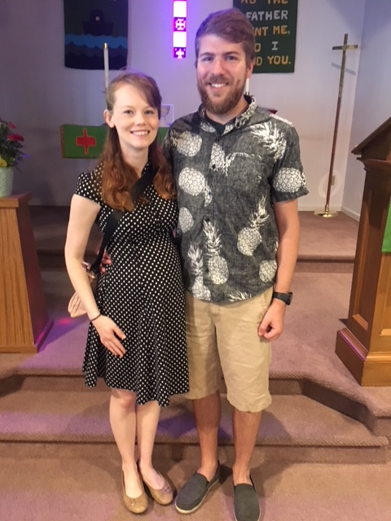
Welcome new members to Calvary Quinderra & Brian Koehl
(and, is that a baby bump?)

Care in the Community
Part Two in a Series on Caring

Do you or someone you know have a problem and don't know where or who to turn to for help?

Yes, we as a church are here to help spiritually and can offer some assistance with problems, but there are many other local agencies and groups in the area that have the knowledge and skills to assist people in specific areas of need.

Most of the time the biggest issue is not knowing where or who to contact for help. Technology has made it easier to get in touch with the right agency or organization that can help you in your time of need: Dial 2-1-1. This is a 24/7 help line provided by the United Way that has trained operators that will help put you in touch with the right people to help you with your issue. They are also a contact point in times of local disasters (severe storms, floods and tornadoes). You can also contact them via text Monday-Friday 8 AM to 5 PM by texting your zip code to 898211. Plus they have a searchable on-line data base that you can access at www.211counts.org.
- Joe
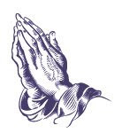
In Our Prayers
In thanksgiving for new life in Christ.

For healing for Stan, Carol, Jackie, Nancy, Marcia, Diane, George, Kristy, Greg, Daryl, Don, Joanne, Arnie, Amy, and Darrick.

For those with cancer, especially Wes, Alex, Don, Diane, and Chris.

For those with chronic illness and have asked for prayer: Richard, Tina, Carrie, Scott, Debra, Sandra, Theo, and Kyle.

For those in the military, especially Dawn, Benjamin, Peter, and Chad.

For those in care facilities or living with assistance, especially, Shirley, Helen, and Gail.

We mourn with those who have lost a loved one in the last month, especially the family and friends of Tom Richter, Gertrude Kaminsky, and JoAnn.

Prayer requests can be made by filling out the form on the Prayer Ministry table in the Gathering Space or by talking to Pastor Julie.
In order to include names on our prayer list, we must have the direct and explicit permission of the person involved.

“God’s Care for Widows: Feeling Secure with Change” Embark on a journey of reflection, healing, and connection facilitated by HFM Hospice on Saturday, August 3rd, 2019, 9 am to 1 pm at Holy Family Memorial Medical Center in the
Manitowoc Room. This is a free event and a complimentary lunch will be provided. Register by calling (920) 320-4231 by July 26th.

Know someone looking for a short term part-time job?

Bonny will be off for the first 3 weeks of September and we are looking for someone to do the custodial work during her absence. We would also include a week of training. If we do not find someone we will be asking for volunteers to take care of some of the important tasks during that period. If you know of someone, please let me or Pastor Julie know.
Thanks,
Joe Bitto

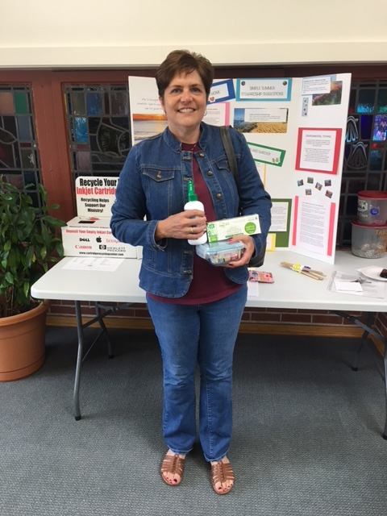
Lori Williams, winner of last month’s drawing from earth friendly entries. Keep entering. It’s good for the earth and next time the winner could be you!

About Our Joint Outdoor Worship Service in Arrow Park on Sunday, August 4…

You can sing the old spiritual song “Down to the River to Pray” and substitute these lyrics into it: “I went down to Lake Michigan to pray…” It works. Perhaps we will try it together on the first Sunday of August as we gather outdoors (hopefully!) in one of the most indisputably beautiful “spots” on this planet. We confess this to be the generous, abundant, life-allowing work and gift of the Creator. If you will consider it, we will pray on the altar of the earth itself, and “study… about that good old way” (back to the song again).

We – certainly should! – know “that good old way”. The “earth is the Lord’s, and the fullness thereof”. It is gift. Gracious. Generous. Unspeakably beautiful, rich, complex. It is “home”, God-given living space. We are beneficiaries, tenants and stewards only, not owners, but beholden, responsible, liable for our care and treatment. We are not “rich kids”, who may kick and trash their toys with complete oblivion.

We also – certainly should! – know that this long-prepared “bubble of life”, this living planet, is under tremendous threat, which, to be brief, is the threat of our own species’ “success”.

Two considerations guide our preparations for worship on August 4. One is a question, and it is for all of us to consider before and during worship: Do you love this planet? It comes from reflections in the prologue of a book written twenty-seven years ago by Dr. Helen Caldicott, entitled “If You Love this Planet”. Caldicott is an Australian pediatrician, who moved to this country (becoming a U.S. citizen), and has been a leading educator on the dangers of nuclear war, radiation, and threats to our environment. She loves children. She loves the planet, meaning the precious, amazing bio-sphere. Her life has been dedicated to preserving and “keeping” them.

Most people, by far, when they stop and consider the question “Do you love this planet?”, realize that the answer is resoundingly “Yes!” Please consider in the week ahead – where/how do you realize, experience, sense, know… that you “love this planet”?

The second consideration for our worship is the covenant, meaning the relationship, spoken of in the opening chapters of Genesis, between the gracious Creator of the constantly-named “good” world, and the human being – aka, you and me – who is placed in the garden and given the purposes of appreciating it, enjoying it, and “tending and keeping” it.

One more reflection – a thought for meditation. Dr. James Lovelock will celebrate his 100th birthday on July 26. A case can be made that we “owe our lives” to him (but also to many others as well). As an independent British scientist, Lovelock helped save all of humanity by developing an invention for detecting CFCs in the atmosphere, which led to discovering the infamous Ozone Hole over Antarctica in the 1980s. This led to the international Montreal Protocol of 1987and the prohibition of human-made chlorines, CFCs. He also is known and beloved internationally for proposing the “Gaia hypotheses” – contending that earth is a single, self-regulating organism (this is now accepted as a founding principle of most climate science). The atmosphere, the oceans, rocks, soil and all living things inter-relate as a self-regulating system that maintains favorable conditions for life. Another way to express this… is that all created beings - “brothers and sisters”, as St. Francis of Assisi named them – which surround us are not “simply” separate entities, things, objects (as modern capitalistic economics would have it), but constitute a living “being”, God’s creation, that appropriately may be contemplated and addressed as “you”, as “thou”. - drj

Who are your Council Members?

This Month: Kerry Rivest

Hi. I am new to the Church Council this year. I always think everyone should know everything about me because I grew up in this church. I started Sunday School when I was so little I almost don’t remember it. My classroom was in the nursery and Pastor Bidwell was our pastor then. I just remember him seeming very tall and having a beard.

Let’s backtrack even more. My grandparents were Leo and Erma Matzke. They attended church at the Community House before our church was even built. Then Grandpa joined the Navy and they were stationed in California and in Florida. They were away when the groundbreaking took place. They returned and started attending the new Calvary Lutheran Church. My mother, Lana Ernst, and both of her sisters were married in our church. I was too.
Then in 2003 Jacob Lee came along and he was baptized here. When he was three he started attending Sunday School and I became a Sunday School helper.

Jacob and I live in Manitowoc now. We have a golden retriever, Rigby, and a cat, Jerome, (don’t ask). I work at Holy Family Memorial as an x-ray technologist that specializes in mammography.
Who Are Your Church Officers?

New Bible Study to Focus on Daniel

Our Monday night bible study of the upcoming Scripture for Sunday continues to meet in the Board Room of the Manitowoc Public Library at 6 p.m. (On the last week of the month, it is in the Balkansky Room). Starting in August, Bruce Hanstedt will be leading the bible study with a focus on the book of Daniel. Bruce is a retired ELCA pastor with years of knowledge and experience to share and we are so thankful for his leadership! For this 4-week study of Daniel, bring your bible and willingness to learn. Plan to stay until 7:30 p.m. because Bruce likes to take a break!

This Month: Lori Williams – Financial Secretary

Hi, I’m Lori Williams. I have been financial secretary for Calvary for the last couple of years. My husband Jim and I have been members of Calvary since 1988. I volunteer at Calvary as a lector, communion assistant, and substitute worship leader. Jim prefers the behind the scenes work of the property committee.
I have taught in the Manitowoc School District for 31 years and currently work as the K-12 Math Specialist. Jim is manager of plant operations for Holy Family Memorial Hospital and Clinics. In our free time, Jim and I enjoy geocaching, four wheeling, biking, and quiet evenings on the patio watching the fire. I also spend a lot of time reading and am hoping to get back to quilting when we retire.

Our daughter Teri, her husband Scott, and our granddaughters Natalie (age 12) and Violet (age 9) live in Manitowoc. Teri teaches first grade at Franklin School in Manitowoc and Scott works for Kohler Company. Our son Christopher and his partner Bethany live in the windy city of Chicago where he works at O’Hare airport and Bethany works in technology support.
August 2019
Sunday | Monday | Tuesday | Wednesday | Thursday | Friday | Saturday
 |  |  |  | 1  6:30 pm Worship  7:00 pm Al-Anon | 2 | 3  9am – 1pm  God’s Care for Widows at HFH  6:00 pm AA
4  10 am Joint Outdoor Worship w/HC at Red Arrow Park  With a potluck picnic to follow. | 5  6 pm Bible Study  Manitowoc Public Library  7:00 pm AA | 6  7:00 pm NA | 7  7:00 pm AA | 8  6:30 pm Worship w/ Communion  7:00 pm Al-Anon | 9 | 10  6:00 pm AA
11  8:30 am Worship w/ Communion  9:30 am Fellowship | 12  Pastor Julie on vacation  6 pm Bible Study  Manitowoc Public Library  7:00 pm AA | 13  6:00 pm Council Meets  7:00 pm NA | 14  6:00pm Finance Com.  7:00 pm AA | 15  6:30 pm Worship  7:00 pm Al-Anon | 16  Gospel Fest | 17  Gospel Fest  6:00 pm AA
18  Pastor Julie on vacation  8:30 am Worship w/ Communion  9:30 am Fellowship  Newsletter Deadline | 19  6 pm Bible Study  Manitowoc Public Library  7:00 pm AA | 20  7:00 pm NA | 21  7:00 pm AA | 22  6:30 pm Worship w/ Communion  7:00 pm Al-Anon | 23 | 24  6:00 pm AA
25  8:30 am Worship w/ Communion  9:30 am Fellowship | 26  6 pm Bible Study  Manitowoc Public Library  7:00 pm AA | 27  7:00 pm NA | 28  Vacation Garden Bible School Day  12:30 – 5pm with free dinner to follow  7:00 pm AA | 29  6:30 pm Worship w/ Communion  7:00 pm Al-Anon | 30 | 31  6:00 pm AA

August 2019 Worship Helpers
Date Greeter/Usher Lector Cantor Comm. Server PP Operator Counters Lay Leader
Th 8/1 | Caroline Curtis | Rita Kreeger | No | None | None | None | LL)  Stan Phelps
Su 8/4 | Jean & Doug Hoffman  Youth may be doing these jobs with your guidance | Ollie Press | No | Doug Hoffman | None | John Kreeger &  Kim Braun | Joint outdoor service at park
Th 8/8 | Bonny & Joe Bitto | Cathy Luebke | No | Cathy Luebke | None | None
Su 8/11 | Sonja & Dave DeVore | Diane Grasee | No | Kerry Rivest | Erin DeVore | Scott Manthei Mark Arneman
Th 8/15 | Garth Landon | Garth Landon | No | None | None | None | LL) ?
Su 8/18 | Doug & Jean Hoffman | Lori Williams | No | Doug Hoffman | Kerry Rivest | Lori Williams & Barb Jensen
Th 8/22 | Bonny & Joe Bitto | Caroline Curtis | No | Roxanne Spiering | None | None
Su 8/25 | Kerry Rivest | Lori Williams | No | Kerry Rivest | Doug Hoffman | Barb Jensen & Teri Zipperer
Th  8/29 | Cathy Luebke & Bill Christoffel | Cathy Luebke | No | Ben Dow | None | None

This rotation is printed only after Bonny has informed the worship helpers and has received no objections. Once in the newsletter, each person is responsible for finding their own substitutes if something changes and they are no longer available.
In an emergency, call Teri at the office – 793-3917, or Bonny – 794-4344. Lectors will still receive the appropriate readings by mail. Thank you for all you do to make worship meaningful for everyone.
The Calvary Caller
1921 Adams Street
Two Rivers, WI 54241

August 2019

A family of Christians
growing in faith through worship and service.

Sundays
8:30 am Worship
9:30 am Fellowship

Summer Schedule
No Calvary Kids or Confirmation Class

Thursdays:
6:30 pm Worship
7:15 Fellowship

